ASSIGNMENT : 2

1.
List three popular apps you use (like Instagram, Zomato, or Spotify) and for each, identify whether it is most similar to IaaS, PaaS, or SaaS. Briefly explain your reasoning for each choice.
ANS :
Three Popular Apps and Their Cloud Service Models
1. Instagram – SaaS (Software as a Service)
Instagram is a SaaS application because users directly use the ready-made software through the mobile app or website without managing servers, storage, or the underlying infrastructure.
2. Zomato – SaaS (Software as a Service)
Zomato is similar to SaaS because it provides a ready-to-use application for ordering food and finding restaurants. Users simply use the service without managing the technology behind it.
3. Spotify – SaaS (Software as a Service)
Spotify is a SaaS application because users access ready-made music-streaming software without needing to manage the servers, databases, or other infrastructure that runs the service.

2.
Create a table comparing IaaS, PaaS, and SaaS with at least three points for each model, using real-world examples such as AWS EC2, Google App Engine, and Office 365.
ANS :

Point | IaaS | PaaS | SaaS
Meaning | Provides virtualized computing resources such as servers, storage, and networking. | Provides a platform and tools for developing and deploying applications. | Provides ready-to-use software over the internet.
User manages | Users manage the operating system, applications, and data. | Users mainly manage their application and data; the provider manages the infrastructure and platform. | Users mainly use the software; the provider manages the application and infrastructure.
Main use | Used to build and run applications with more control over infrastructure. | Used by developers to create, test, and deploy applications without managing servers. | Used by end users to access software without installing or maintaining the underlying infrastructure.
Example | AWS EC2 | Google App Engine | Microsoft 365 (Office 365)

3.
Sign up for a free AWS account (or use an existing one), navigate to the EC2 dashboard, and launch a new t2.micro EC2 instance running Ubuntu 22.04. Take a screenshot of your running instance in the AWS console.<br><br><em><strong>Hint:</strong> Use the 'Launch Instance' button and select the free tier eligible Ubuntu AMI.</em>
ANS :
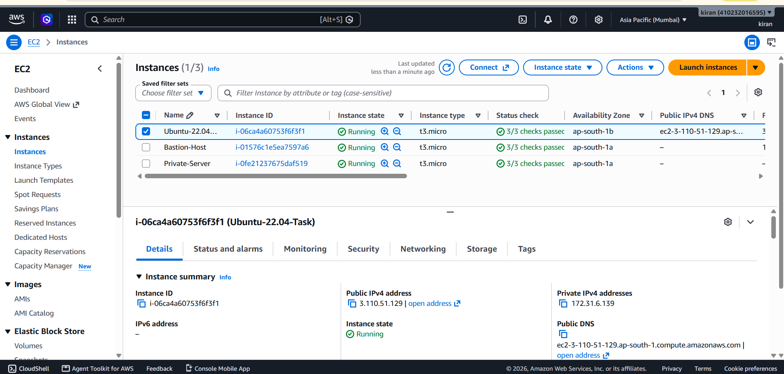

4.
After your EC2 instance is running, connect to it using SSH from your local terminal or an online SSH client. Run the command 'uname -a' and note the output.<br><br><em><strong>Hint:</strong> You may need to use the .pem key file downloaded during instance setup.</em>
ANS :
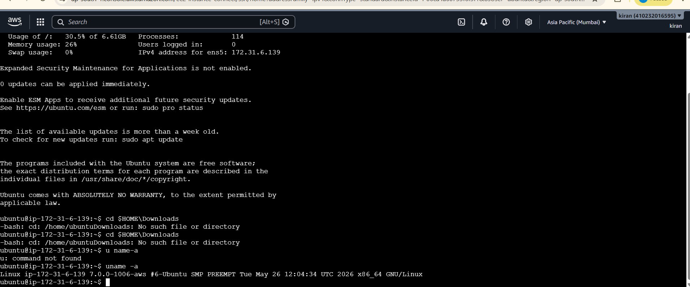
5.
Suppose you want to host a simple static website for your college fest using your EC2 instance. List the basic steps you would follow after launching the instance to make your site accessible to everyone. Write 3-5 steps in order.
ANS:
1. Launch an EC2 instance and connect to it using SSH.
2. Install a web server such as Apache or Nginx on the EC2 instance.
3. Upload the static website files (HTML, CSS, images, etc.) to the web server’s directory.
4. Configure the Security Group to allow inbound HTTP (port 80) traffic from anywhere (0.0.0.0/0).
5. Copy the EC2 instance’s public IP address and open it in a web browser. The website will then be accessible to everyone.

